**Second half of files** – letter = treatment; first two numbers = rep; third number = channel

Grape clean treatment Wild clean treatment

=92

=48

=44

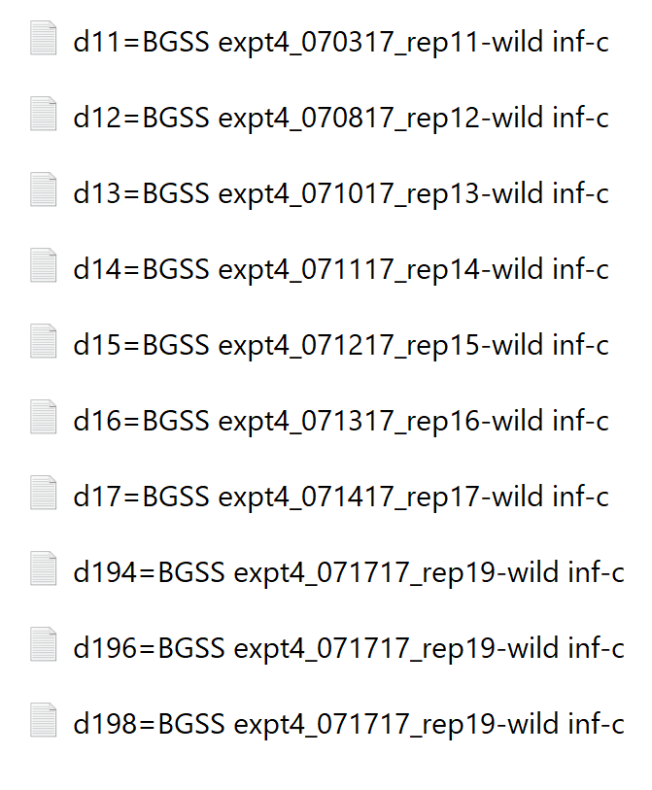Grape infected treatment Wild infected treatment

=28

=26

=22

=96

=88

=84